# 1. Project or Company Profile

**Project Profile**

|  |  |
| --- | --- |
| **Project Title** | Stock Price Prediction using Machine Learning |
| **Project category** | Web Application |
| **Objective** | To Predict the stock price based on the past and upcoming events. |
| **Front End** | Django |
| **Back End** | Django, Python |
| **Tool** | Anaconda, Google Colab |
| **Server** | XAMP |
| **Documentation Tool** | Office 365 |
| **Company Name** | MADHDA BUSINESS SOLUTIONS PVT LTD |
| **Internal Guide** | Dr. Jigneshkumar A. Chauhan |
| **External Guide** | Pravin Dangar |
| **Developed By** | Preyash Sanjay KaPatel (1803421003) |
| **Group No** | 19 |

**About the Company**

Company provides a complete solution with high performance with helping hand from startup level to the enterprise level.

We provide Microsoft Dynamics ERP solutions to our clients worldwide. We work closely to provide consulting, maintenance, Implementation support, Upgrades, Re-architect to our client. To make your company and products smarter are more successful.

* We provide custom solution to our client.
* An employee is the most valuable asset for an organization.
* We design, implement and manage your Microsoft Dynamic ERP.
* We utilize our expertise in providing sustainable enterprise solutions to customers and help their businesses maximize potential.
* For us every business is built on good relation with client.
* The leaders at Madhda about their employees’ well-being, happiness and success.
* We are driven by a set of guiding principles which dictate our decisions and responsibilities towards our people and customers.
* To provide businesses with the ERP software and knowledge they need to succeed in a competitive market.
* We conduct business ethically.
* We embrace positive change, innovation, and continuous improvement.

In return our employees feel recognised and appreciated for their contributions to the company.

# 2. Functional Requirement Specification

# 2.1 Module Specification

1. Login:
   * Admin and Account Holder can access website by successfully login
2. Watchlist:
   * User can add remove stock from watchlist.
3. Holdings:
   * Here user can see there stock holding if they have.
4. Predictions:
   * In this module user can predict the stock price.

# User Specification

1. Prediction:
   * There should be option to predict the share price.
2. Recording of stock for Study:
   * Learner should be able to add get latest price.
3. Buy and Sell:
   * Learner should be able to buy and sell stock at any price for study purpose.

# 3.1 About Existing System

The existing system works as follow:

* Money related transaction require high alertness of statistical insights of history and future events, in such case taking decision of stake sale, hold or buy are difficult.
* Before taking decision, we need to look at the past data, stock patterns, Recent news and judging the price takes time and it might end up in slow decision, incomplete information etc.
* Taking the Stake sale/buy/Hold based on emotion and incomplete information may perform false prediction.

# 3.2 Need for new system

1. Rapid Decision:
   * User can take decision rapidly as it is performed autonomous.
2. Improved Accuracy:
   * User can use the result to take decision for stake sale or hold or buy
3. Based on Historic data:
   * Prediction are based on historic data and past events.

# Machine Learning:

* Stock price prediction is an important decision in order to gat benefit from stock market.
* To predict the stock Price I have used Artificial Neural Network, Which contain three layers:
  + Input Layer : We have number of features equal to number on neurons in input layer
  + Hidden Layer : Set of neurons to store what was learned ( can be modified accordingly )
  + Output Layer : Using only one output layer neuron as we are using it for regression problem.
* Creating Indicator Functions is also important to create bias in prediction based on what is more important
* Following are the Indicator for Stock Price Prediction:
  + RSI (Relative Strength Index):
  + MFI (Money Flow Index)
  + EMA (Exponential Moving Average)
* RSI (Relative Strength Index):
  + Measures speed and change of price movements.
    - It ranges in between 0 and 100
  + We consider overbought above 70 and oversold below 30 (generally)
    - RSI = 100 – [100 / ( 1 + (Average of Upward Price Change / Average of Downward Price Change ) ) ]
* MFI (Money Flow Index):
  + Related to RSI but incorporates volume too where RSI considers prices only
    - Typical Price = (High + Low + Close)/3
  + Next, Money Flow (not the Money Flow Index) is calculated by multiplying the period's Typical Price by the volume.
    - Money Flow = Typical Price * Volume
* EMA (Exponential Moving Average):
  + SMA = avg of price data,
  + EMA = more weight to data which is more current.
  + EMA is more sensitive to price movement and it used to determine trend direction
  + EMA = (K x (C - P)) + P
  + where,
    - C = Current Price
    - P = Previous periods EMA (A SMA is used for the first periods calculations)
    - K = Exponential smoothing constant

# 4. Technical Requirement Specification

# 4.1 Hardware Requirement (Minimum)

* Client Side:
  + Hardware Requirement:
  + Basic CPU with 700 MHz Speed
  + 1 GB RAM
* Server Side:
  + Inter i3 10th generation
  + GB RAM
  + 250 mb Space in SSD

# 4.2 Software Requirement (Minimum)

* Client Side:
  + Chrome with 68.0.3440.75 or above Version
  + Good Internet Speed
* Server Side:
  + Chrome with 68.0.3440.75 or above Version
  + High Speed Internet
  + Google Colab
  + Webpage IDE
  + Github Desktop

# 5. System Flow Chart

# System Flow Chart Admin

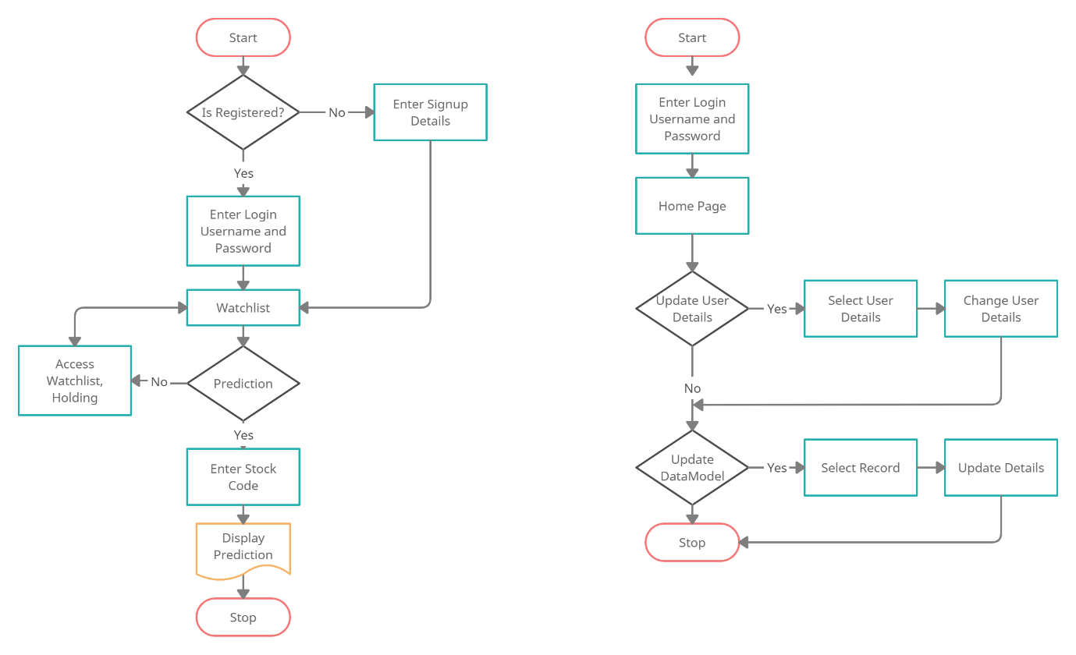

## System Flow Chart User

## 

# 6. UML Diagrams

# 6.1 Use-case Diagram

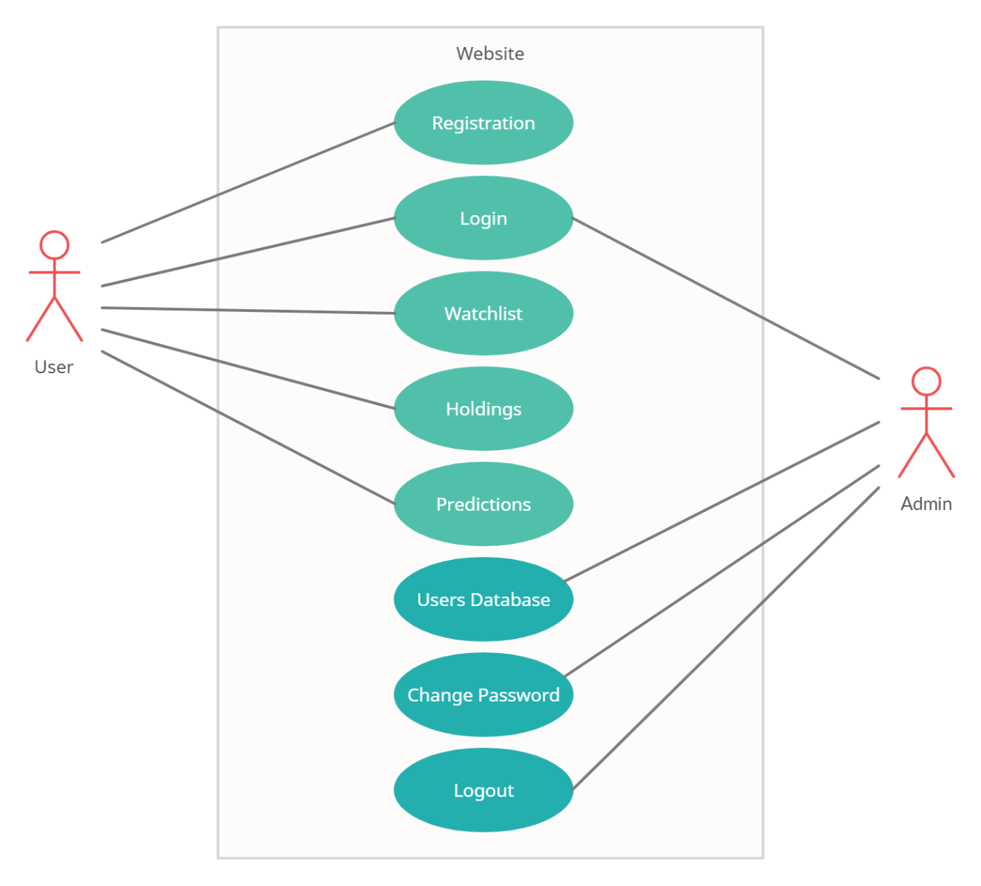

# 6.2 Activity Diagram

**Activity Diagram for Admin**

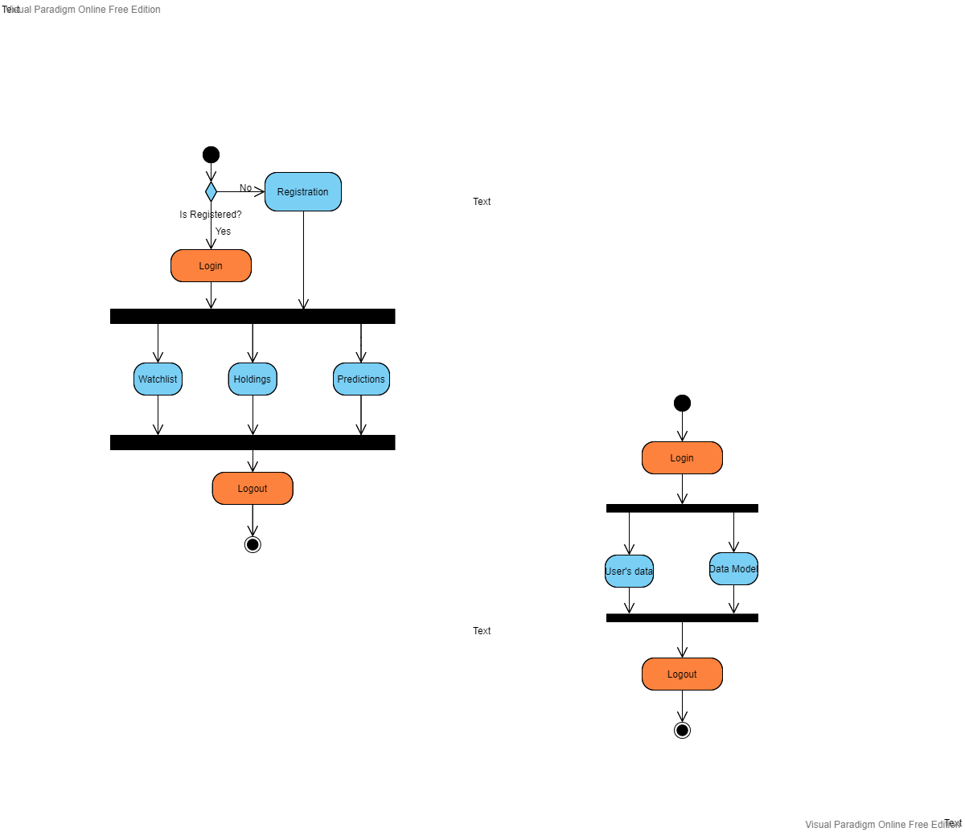

**Activity Diagram for User**

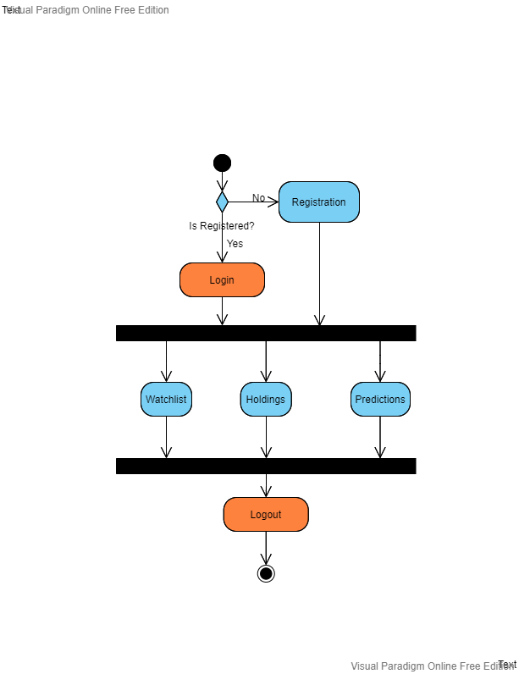

# 6.3 Class Diagram

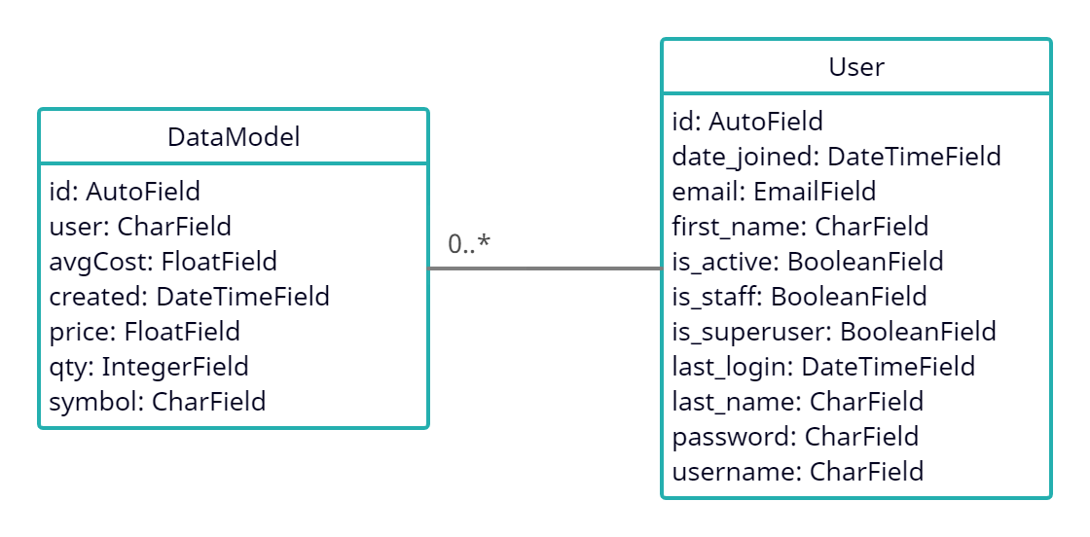

# 6.4 Sequence Diagram

**Sequence Diagram for Admin**

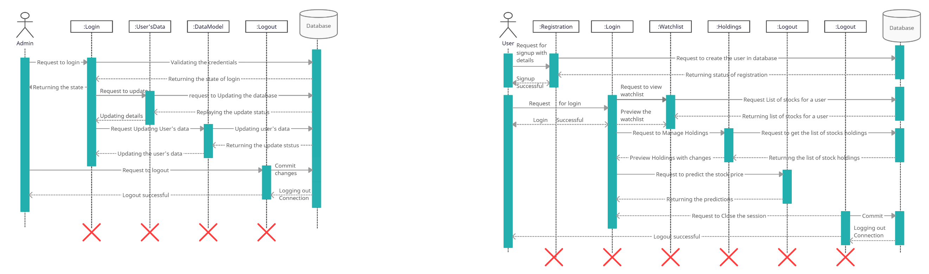

**Sequence Diagram for User**

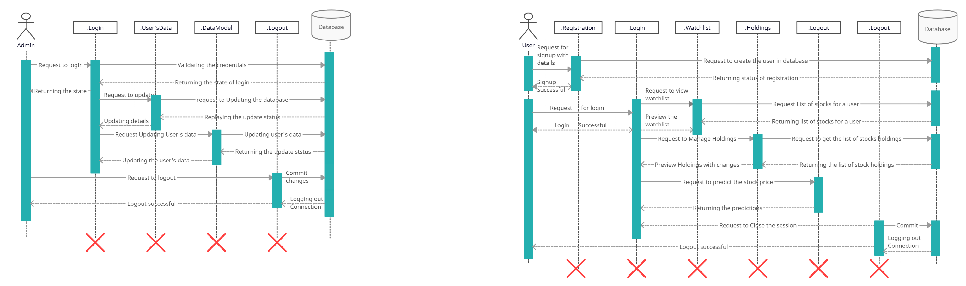

# 6.5 Deployment Diagram

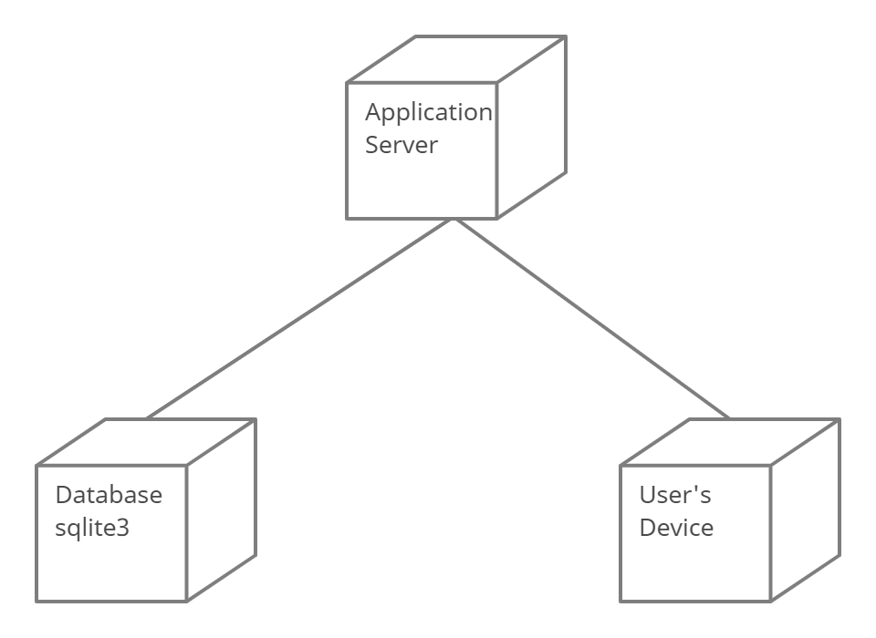

# 7. Data Dictionary

**Name: DataModel**

**DESCRIPTION:- Represents stock holding and watchlist Primary Key: id**

|  |  |  |  |  |
| --- | --- | --- | --- | --- |
| **Sr.No** | **Field Name** | **Data Type** | **Constraint** | **Description** |
| 1 | id | IntegerField | Primary Key | Represent Record id |
| 2 | user | CharField | Not Null | Represent registered User |
| 3 | avgCost | FloatField | Not Null | Represent Average cose |
| 4 | created | DateTimeField | Not Null | Represent stock addition date and time |
| 5 | price | FloatField | Not Null | Represent last updated price |
| 6 | qty | IntegerField | Not Null | Represent quenty |
| 7 | symbol | CharField | Not Null | Represent stock symbol |

**Name: User**

**DESCRIPTION:- Represents users’s details Primary Key: id**

|  |  |  |  |  |
| --- | --- | --- | --- | --- |
| **Sr.No** | **Field Name** | **Data Type** | **Constraint** | **Description** |
| 1 | id | IntegerField | Primary Key | Represent user id |
| 2 | Date_joined | DateTimeField | Not Null | Represent date of joining |
| 3 | email | EmailField | Not Null | Represent Email id of user |
| 4 | First_name | CharField | Not Null | Represent First Name |
| 5 | Is_active | BooleanField | Not Null | Represent user status |
| 6 | Is_staff | BooleanField | Not Null | Represent user is staff member or not |
| 7 | Is_superuser | BooleanField | Not Null | Represent user is super user or not |
| 8 | last_login | DateTimeField | Not Null | Represent last login date and time |
| 9 | last_name | CharField | Not Null | Represent user’s last name |
| 10 | Password | CharField | Not Null | Represent password |
| 11 | username | CharField | Not Null | Represent username |

# 8. Input & Output Design

**Home Page**

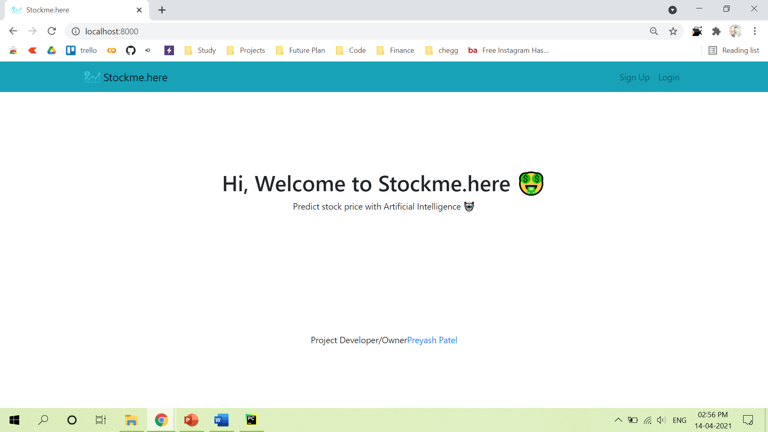

**Signup Page:**

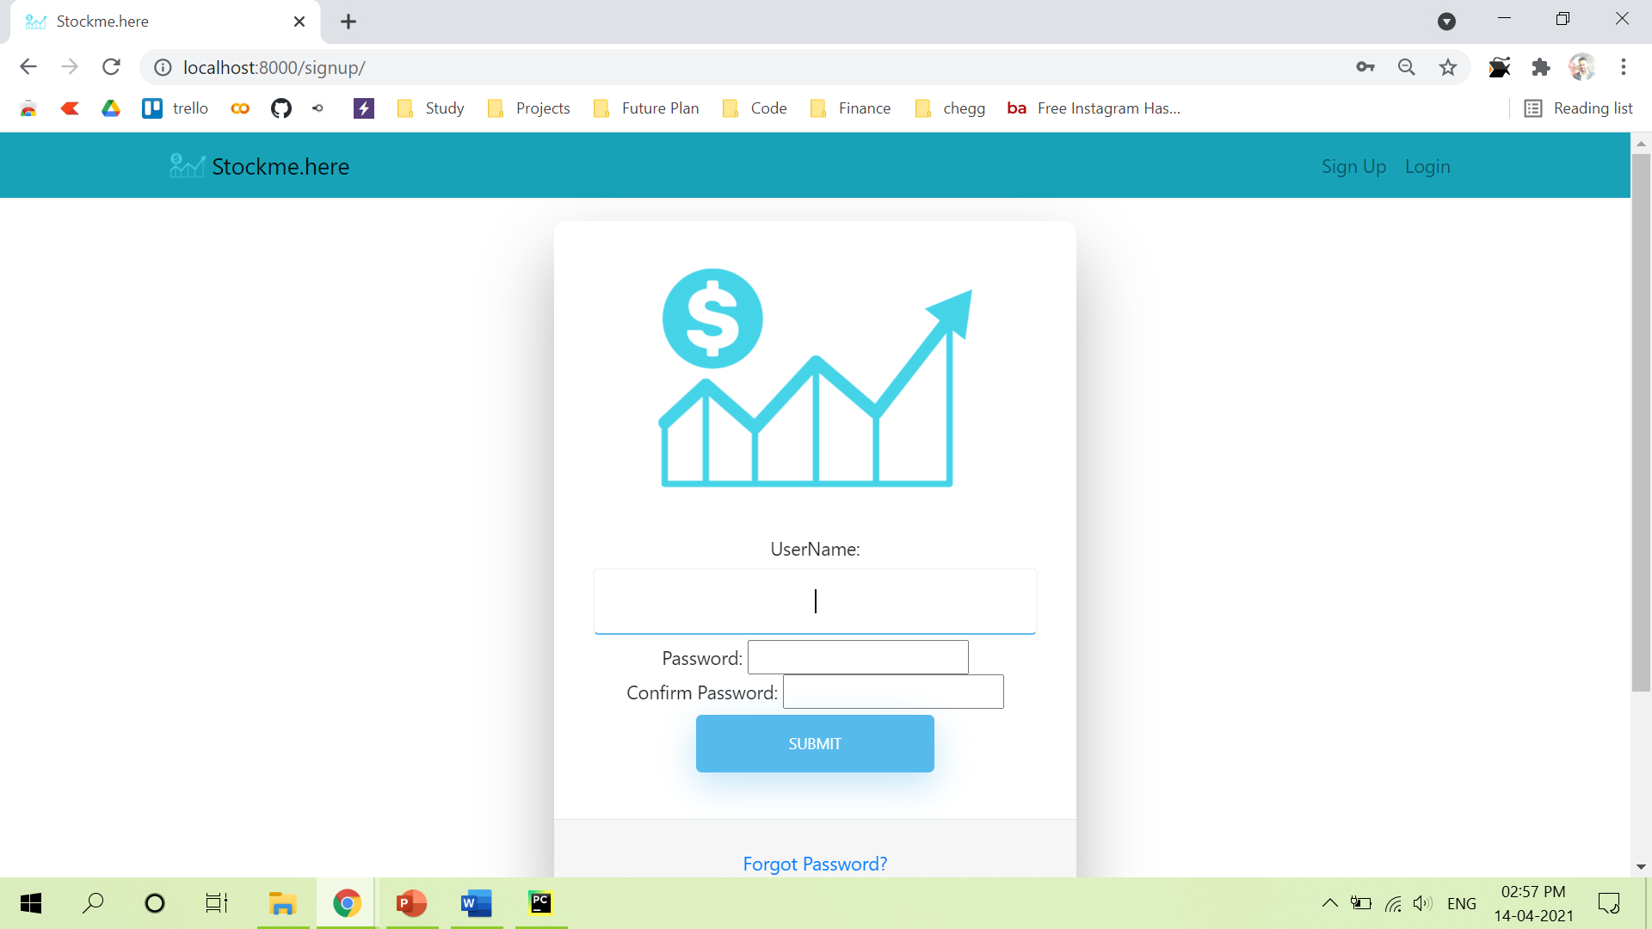

**Signup Credential Validation:**

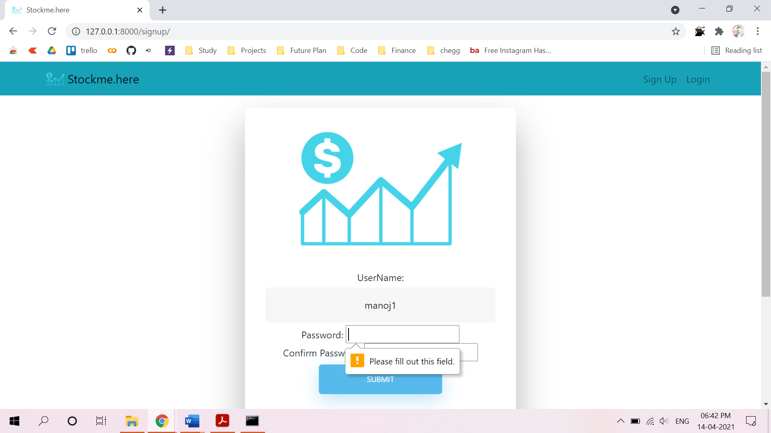

**Login Page:**

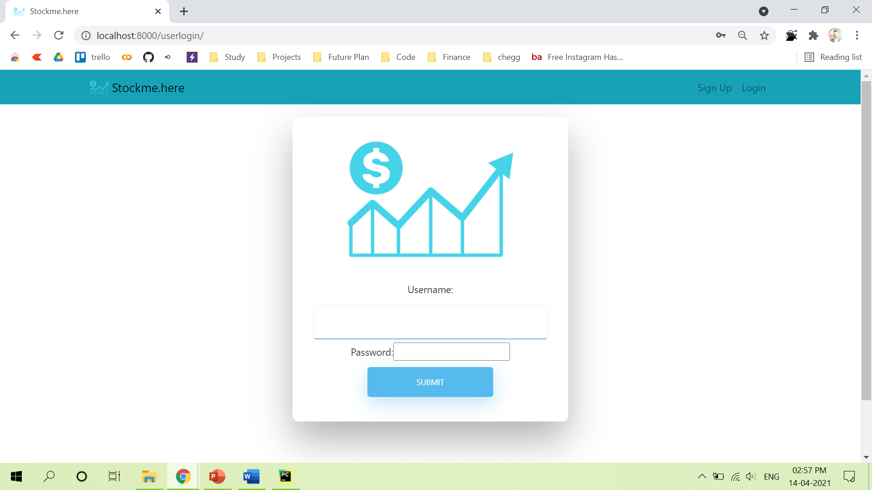

**Login Credential Validation:**

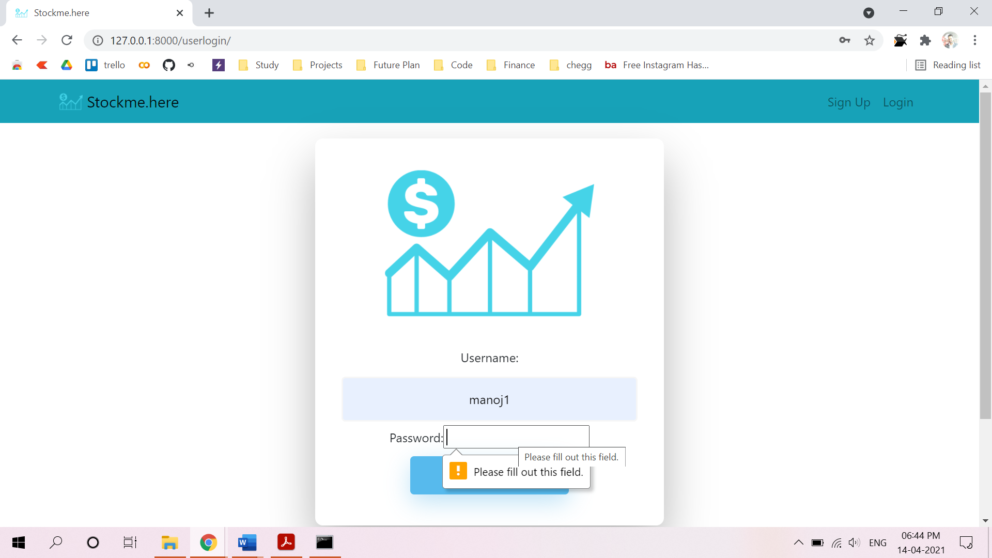

**Home after login**

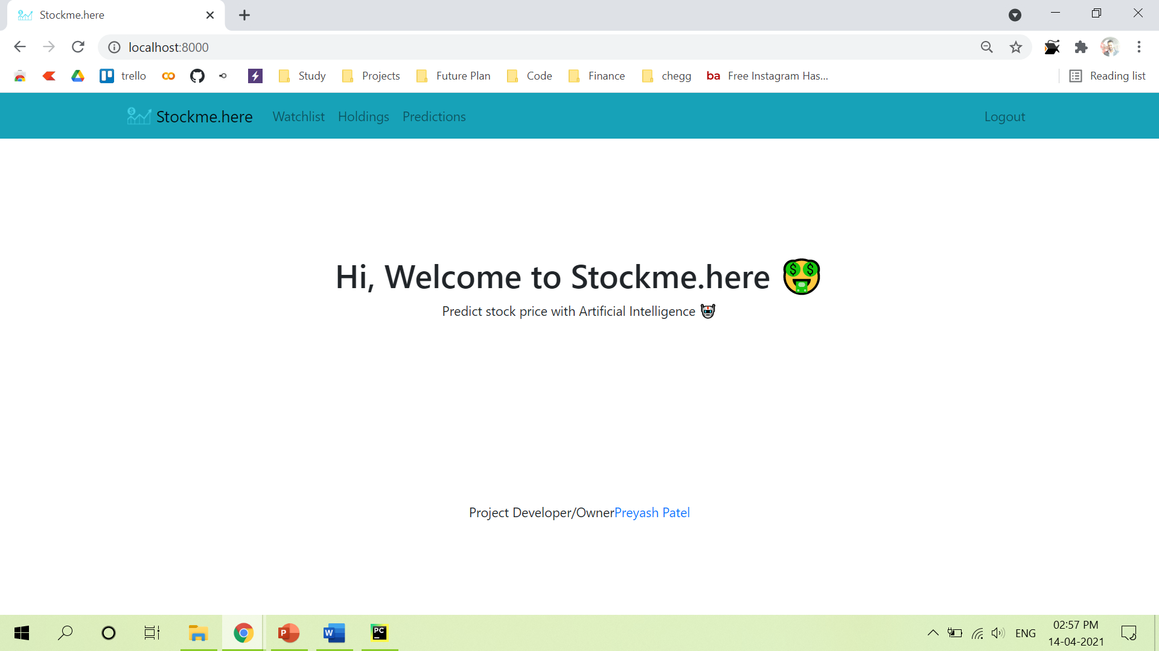

**Watchlist Page**

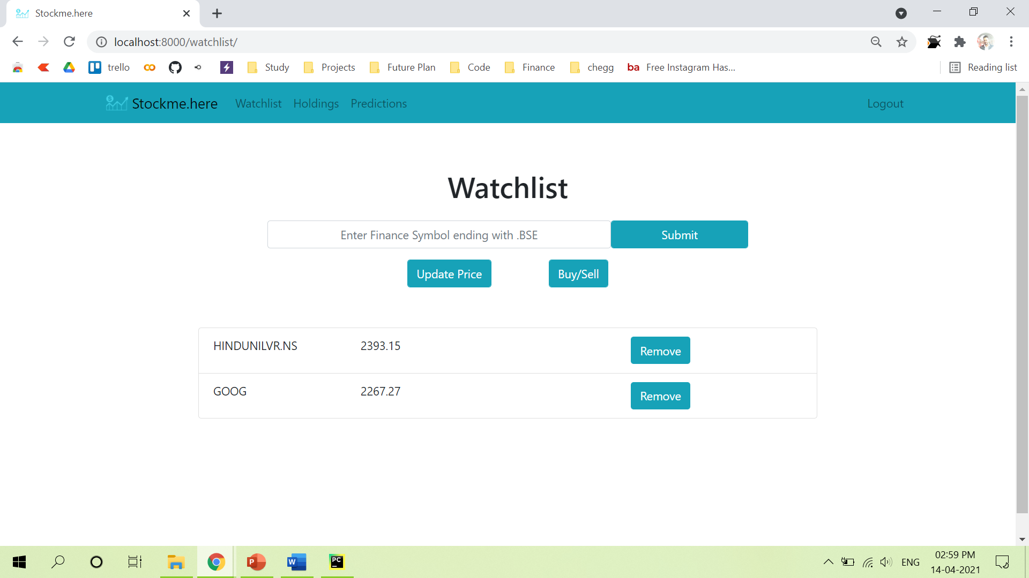

**Holdings Page**

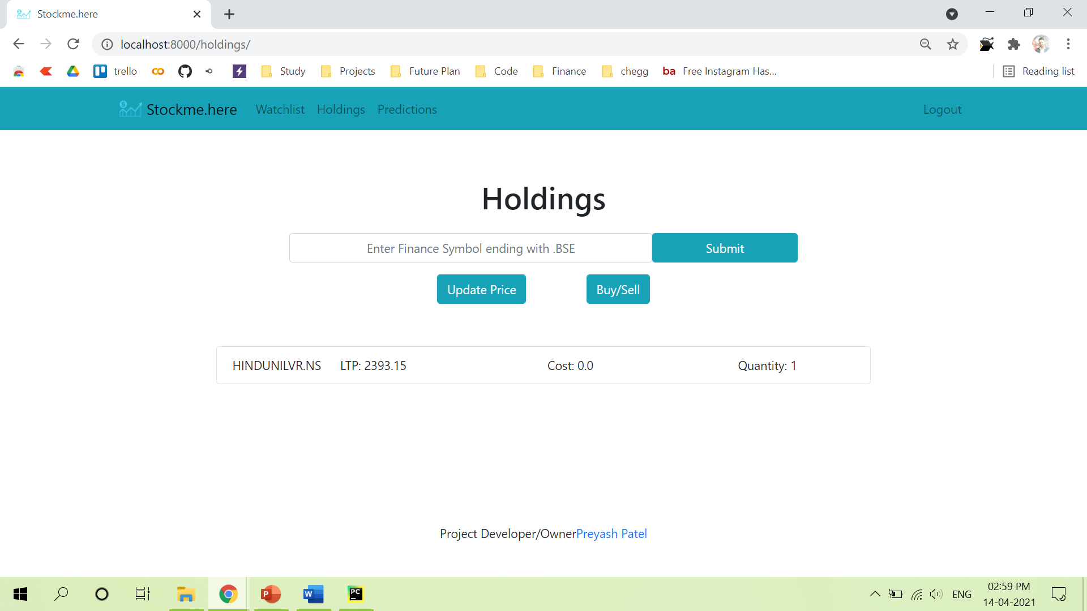

**Prediction Page**

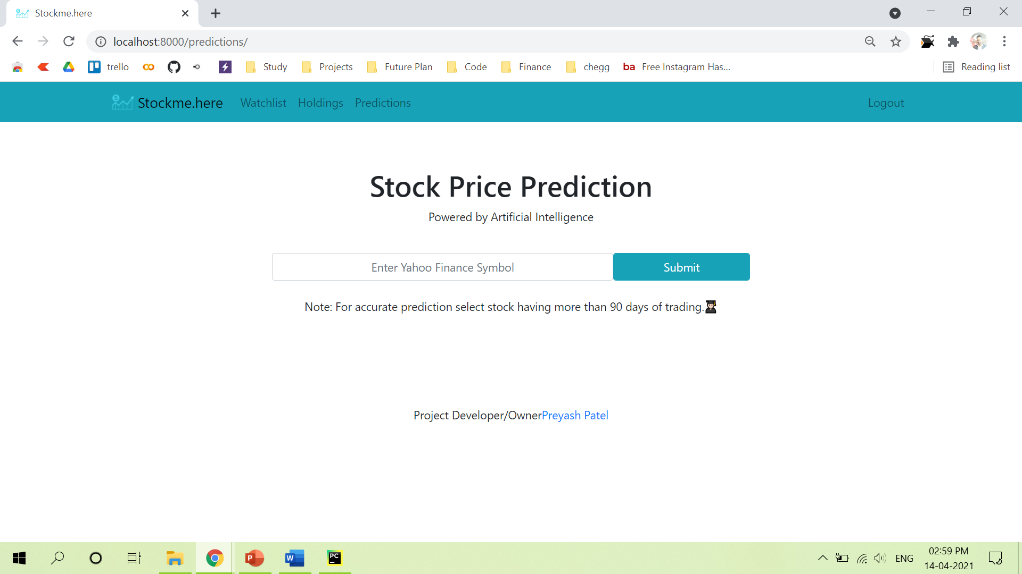

**Prediction Page**

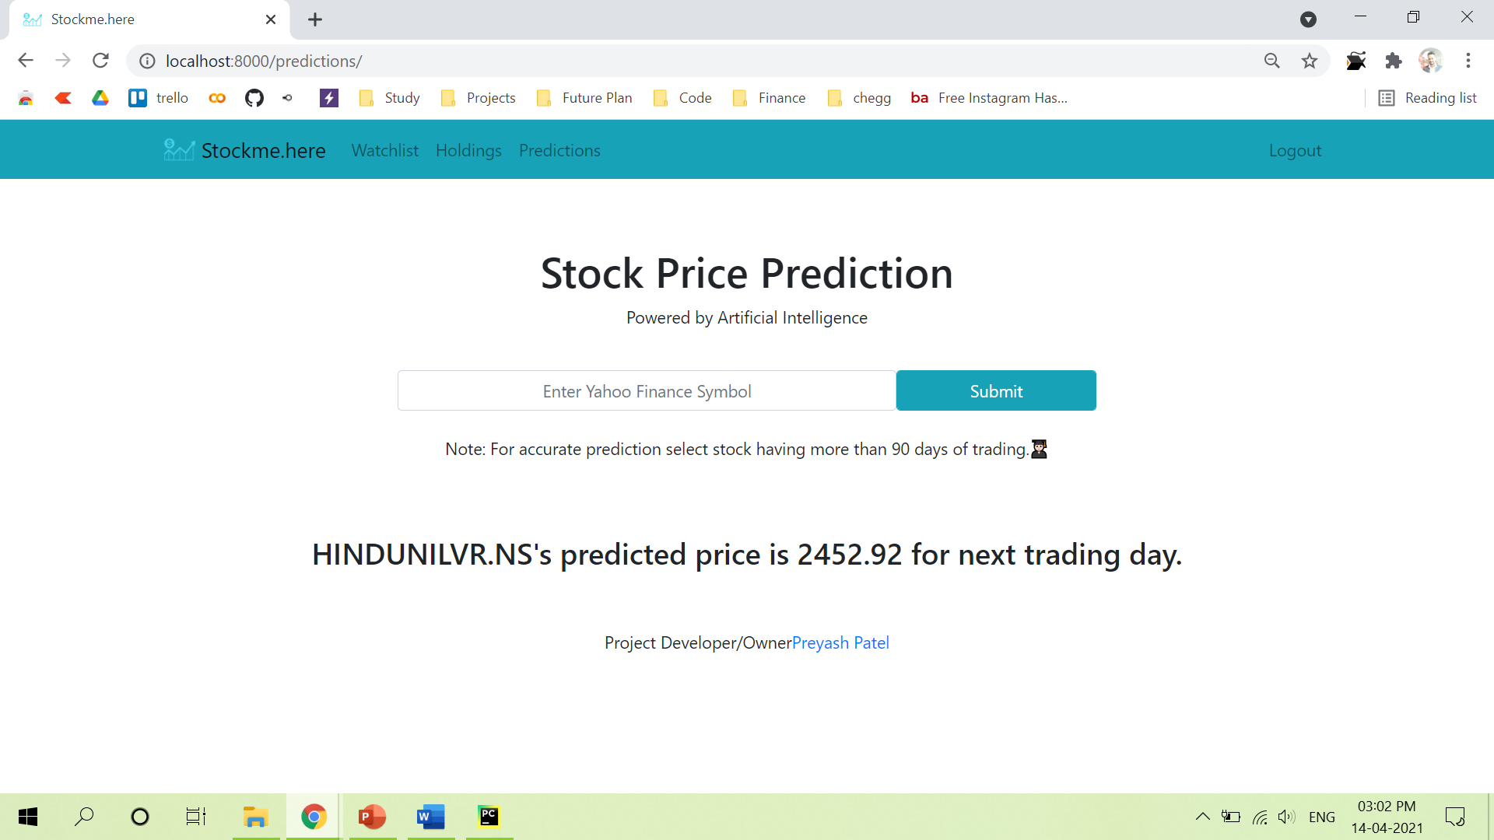

**Admin Login Page**

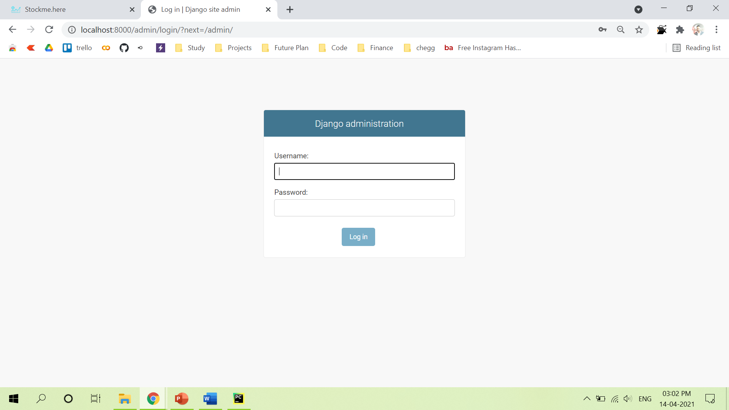

**Admin Login Credential Validation:**

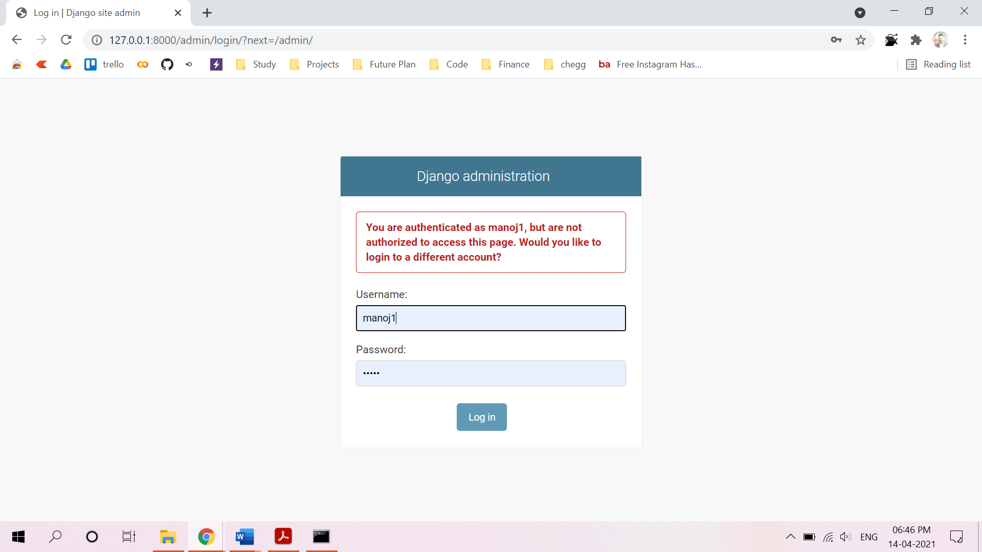

**Admin Home Page**

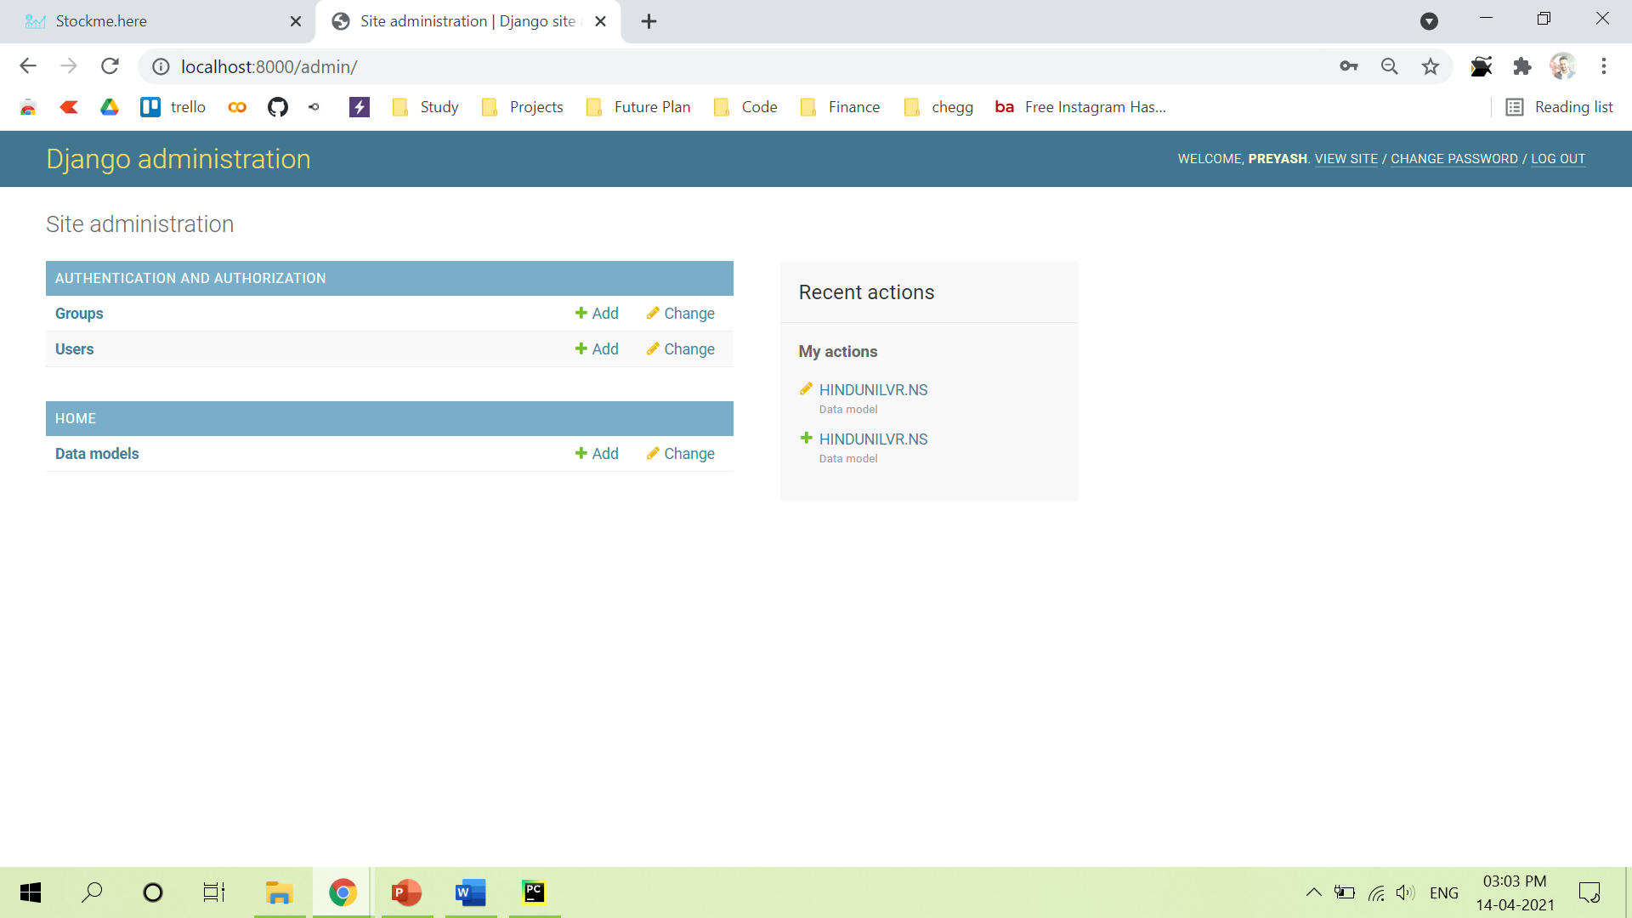

**Admin User’s List**

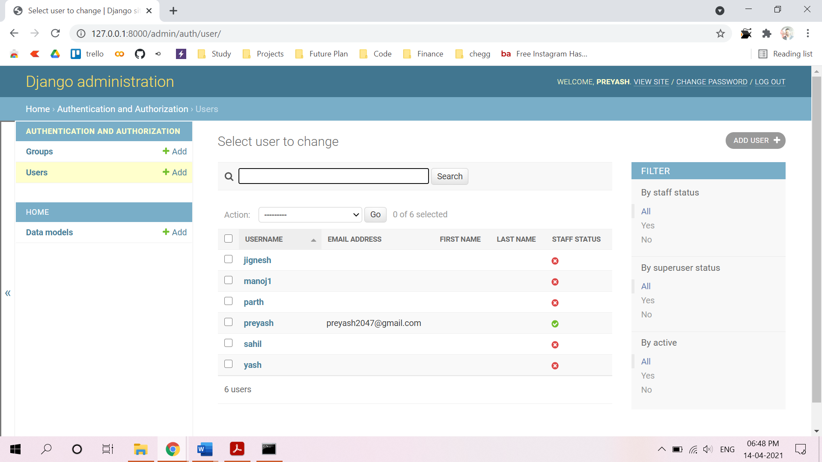

**Admin Add User/Super User Page**

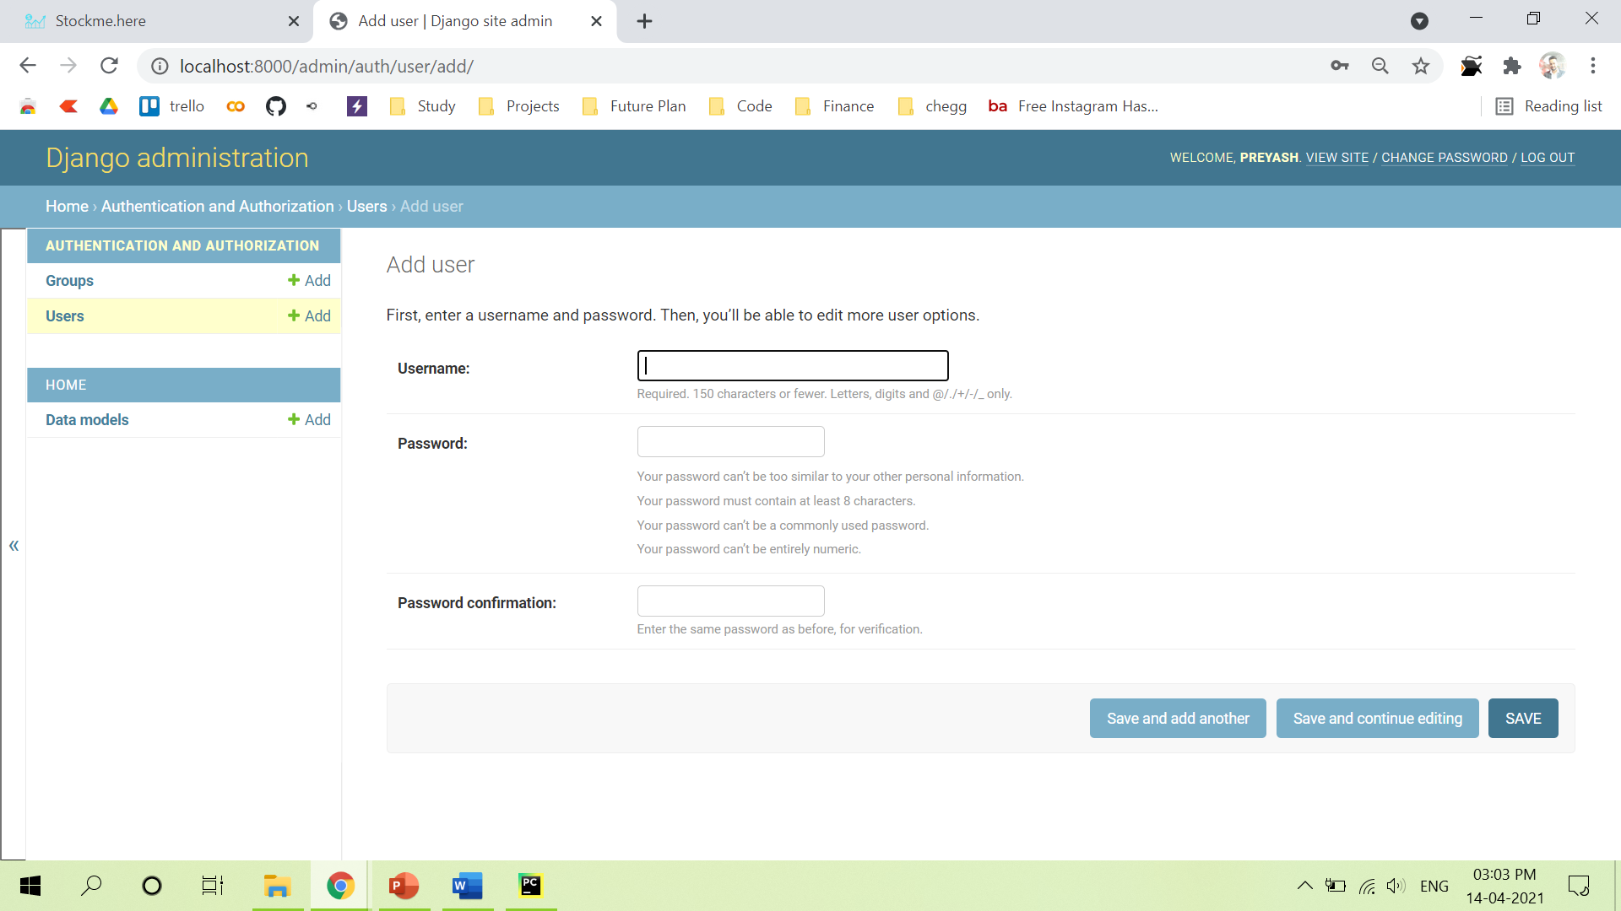

**Admin DataModel Page**

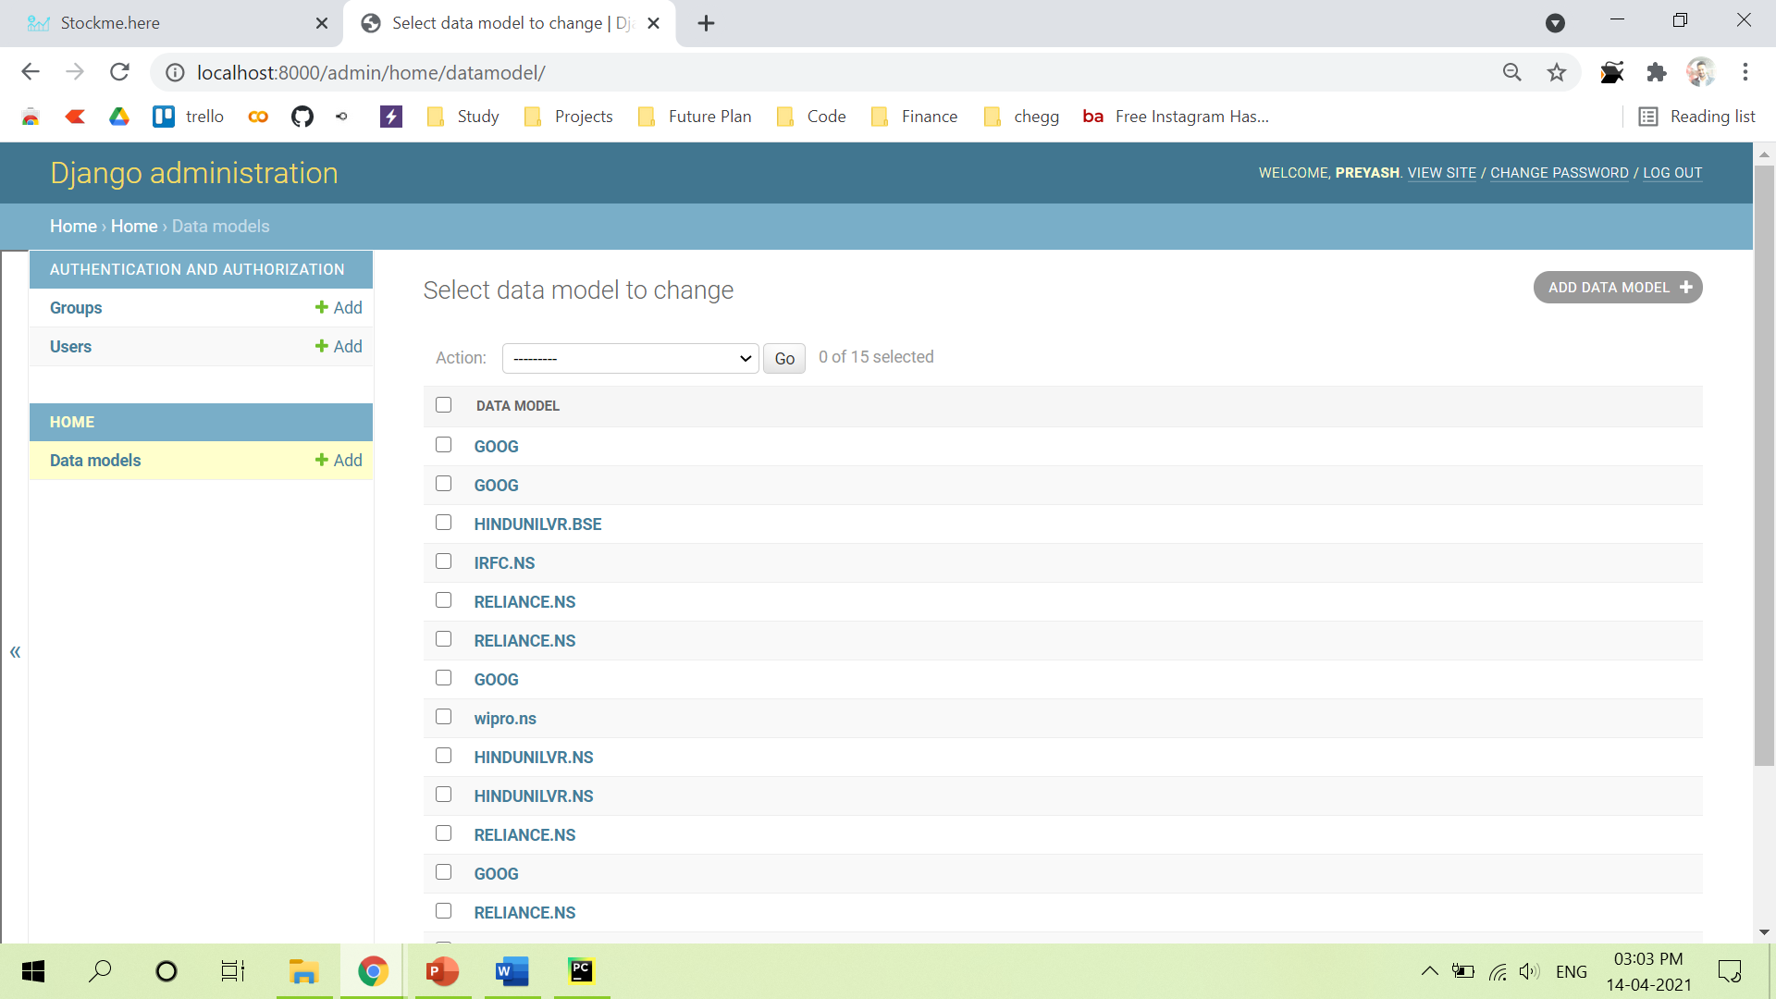

**Admin Add DataModel Page**

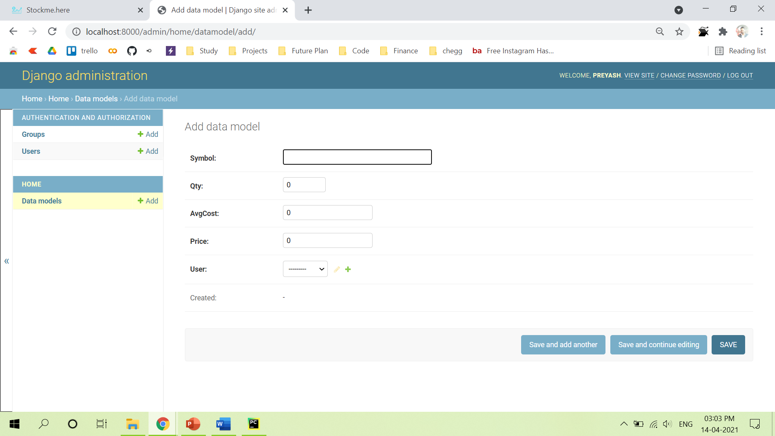

**Admin Change Password Page**

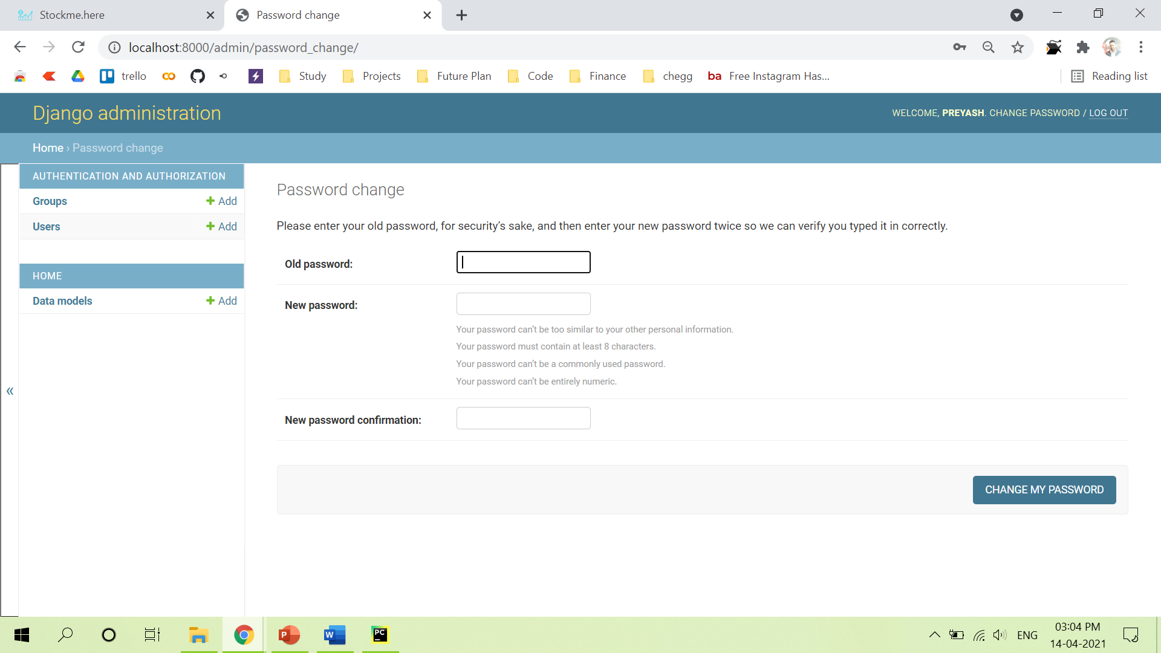

**Admin Logout Page**

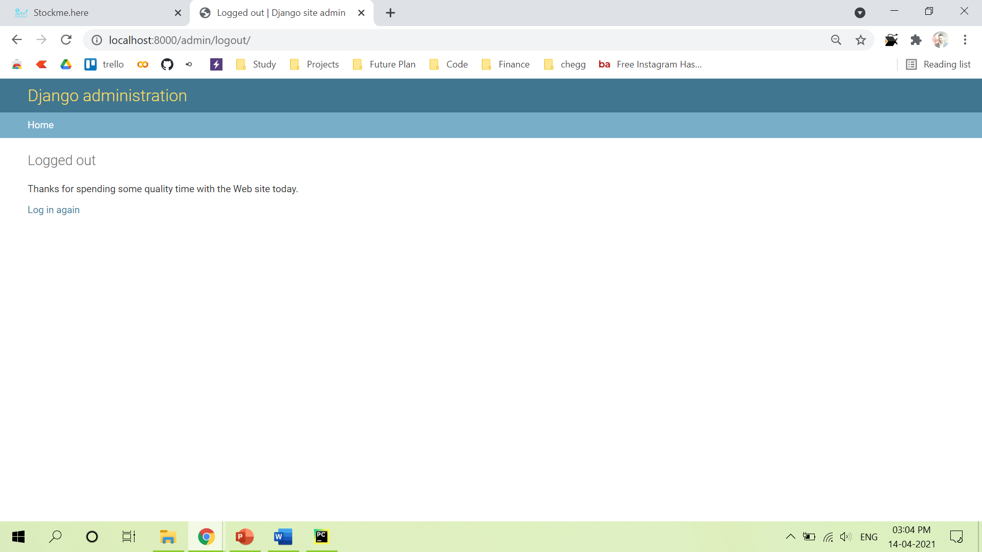

# 9. Testing

**Testing For Login/Signup Validation**

|  |  |  |  |
| --- | --- | --- | --- |
| Sr.No | Validation Checking | Excepted Result | Test Result |
| 1 | Usename | Not Null and Unique | Pass |
| 2 | Password | Not null | Pass |
| 3 | Confirm Password | Not null | Pass |

**Testing For Watchlist**

|  |  |  |  |
| --- | --- | --- | --- |
| Sr.No | Validation Checking | Excepted Result | Test Result |
| 1 | Symbol | As per Yahoo Finance | Pass |

**Testing For Holding**

|  |  |  |  |
| --- | --- | --- | --- |
| Sr.No | Validation Checking | Excepted Result | Test Result |
| 1 | Symbol | As per Yahoo Finance | Pass |
| 2 | Quantity | Greater then Zero | Pass |

**Testing For Prediction**

|  |  |  |  |
| --- | --- | --- | --- |
| Sr.No | Validation Checking | Excepted Result | Test Result |
| 1 | Symbol | As per Yahoo Finance | Pass |

# 10. Future Enhancement

* Implement NLTK to have impact of News on Stock Price Prediction
* Speeding up the Model training time
* Maintain prebuilt model for faster response
* News update for respective stock
* Stock’s Fundamentals view

# 11. Bibliography / References

**Books References**

* Hands-On Machine Learning with Scikit-Learn, Keras, and TensorFlow: Concepts, Tools, and Techniques to Build Intelligent Systems
* Python Machine Learning

**Web References**

* <https://www.djangoproject.com/>
* https://in.finance.yahoo.com/
* <https://www.python.org/>
* http://tensorflow.org/
* http://keras.io/